**SOFTWARE ENGINEERING LAB**

**NAME: BH.LEKHANA REG NO: 211FA04190 SECTION 3C BATCH- 01**

Project-1:

A Point-Of-Sale (PoS) System:

A POS system is a computerized application used to record sales and handle payments; it is typically used in a retail store, it includes hardware components such as a computer and bar code scanner, and software to run the system. It interfaces to various service applications, such as a third-party tax calculator and inventory control. These systems must be relatively fault tolerant; that is, even if remote services are temporarily unavailable they must still be of capturing sales and handling at least cash payments. A POS system must support multiple and varied client-side terminals and interfaces such as browser, PDAs, touch-screens.

**USE CASE DIAGRAM :**

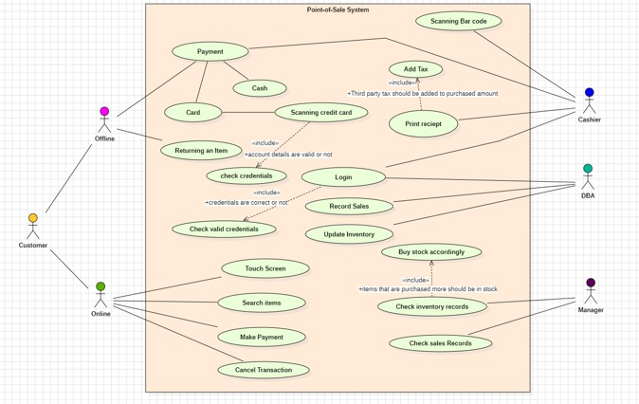

**ACTIVITY DIAGRAM :**

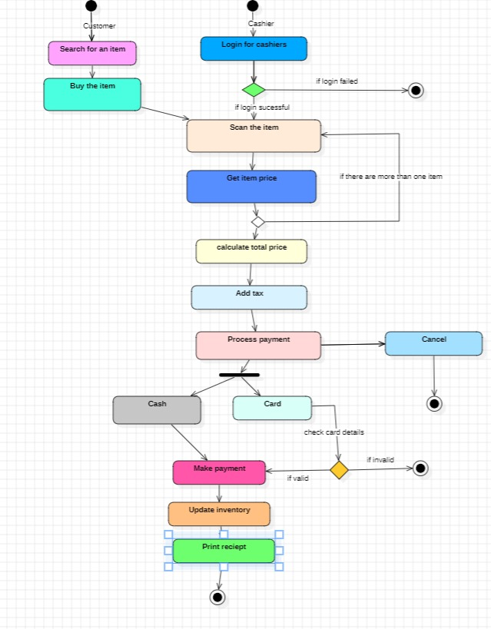

**SEQUENCE DIAGRAM:**

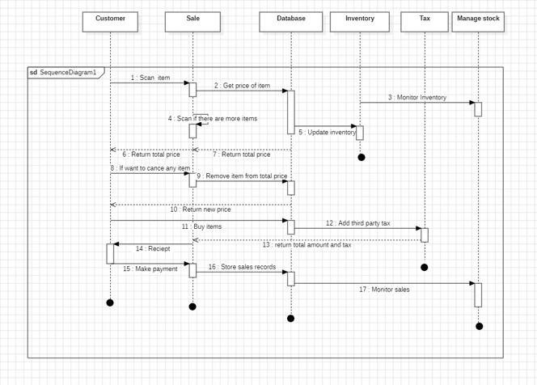

**STATECHART DIAGRAM:**

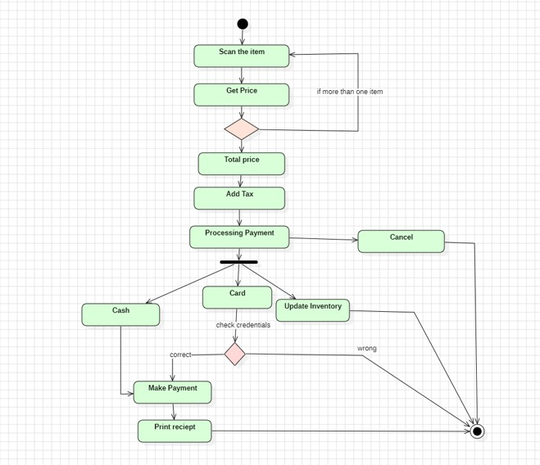

**CLASS DIAGRAM :**

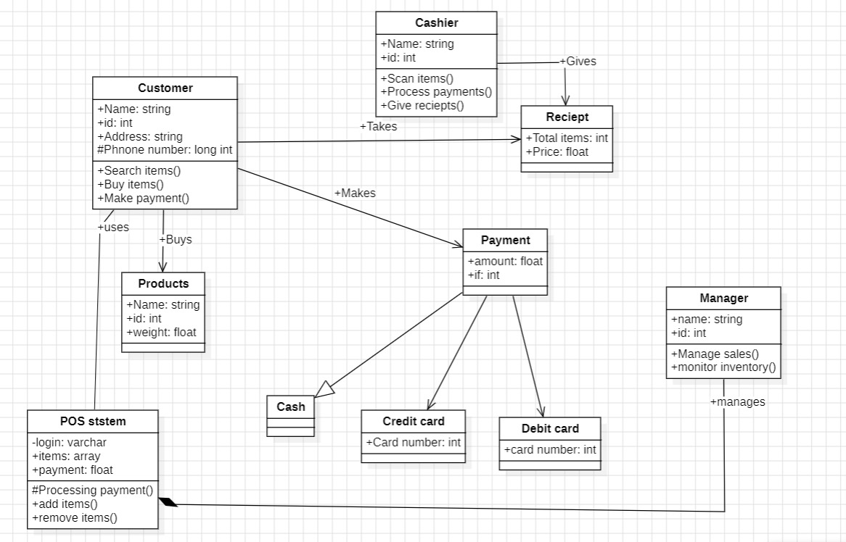

Project-11:

Fule Delivery System

Draft Software Requirement Analysis for the following Problem Statement: Fuel Delivery System: An unattended petrol (gas) pump system that includes a credit card reader. The customer swipes the card through the reader and then specifies the amount of fuel required. The fuel is delivered, and the customer’s account debited.

**USECASE DIAGRAM :**

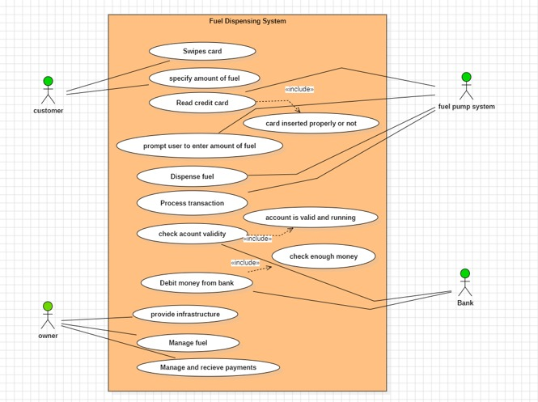

**ACTIVITY DIAGRAM :**

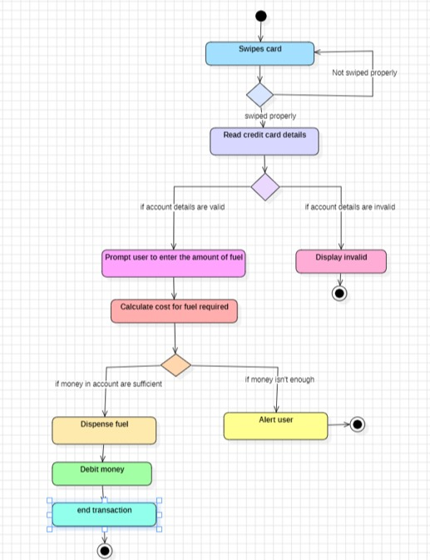

**SEQUENCE DIAGRAM :**

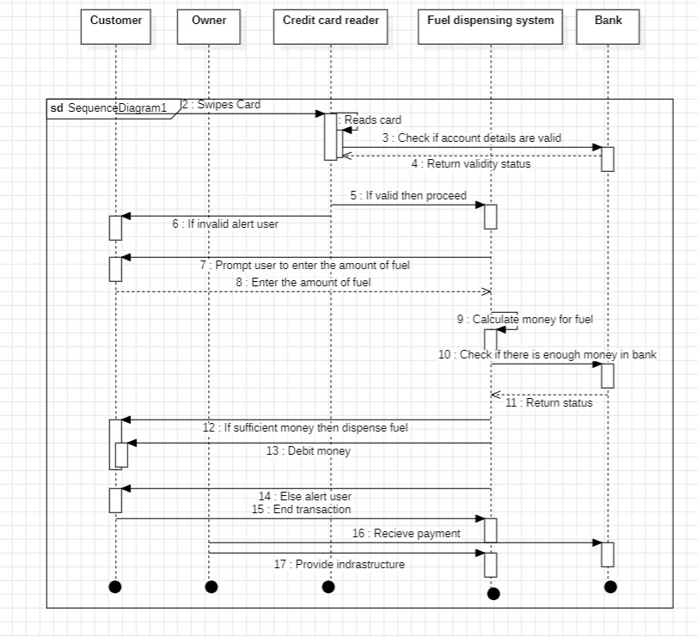

**CLASS DIAGRAM :**

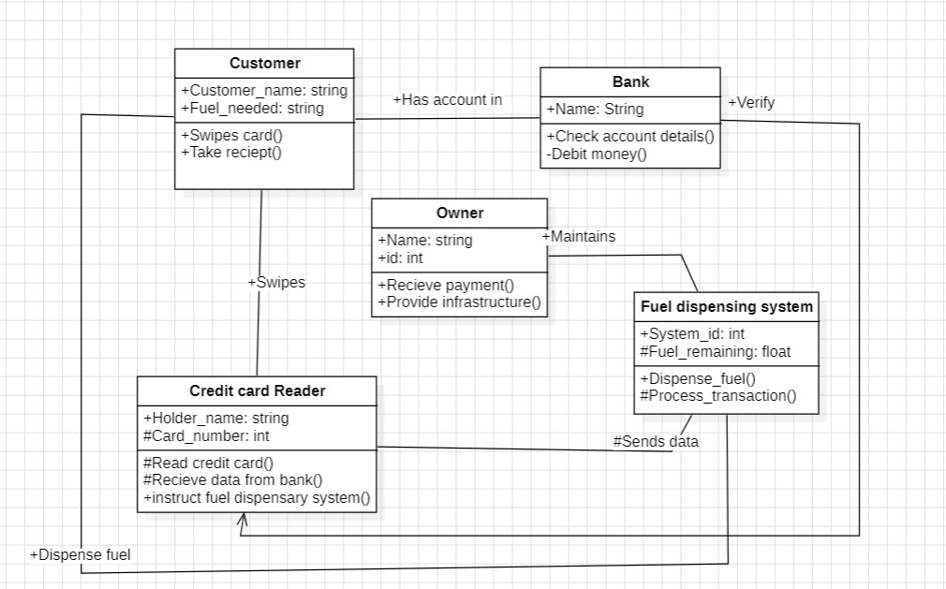

**STATE CHART DIAGRAM :**

